The lads from the Wilts & Dorset SAC enjoyed a great days fishing aboard Predator II.
The morning was spent drifting for Tope which resulted in 14 being landed with the biggest falling to Jim weighing in at just over 30lbs.
The afternoon was spent at anchor and Kerry managed to land his first Undulate Ray.
Not be out done his son, Tim, caught his first Undulate which unfortunately for Kerry was bigger!!
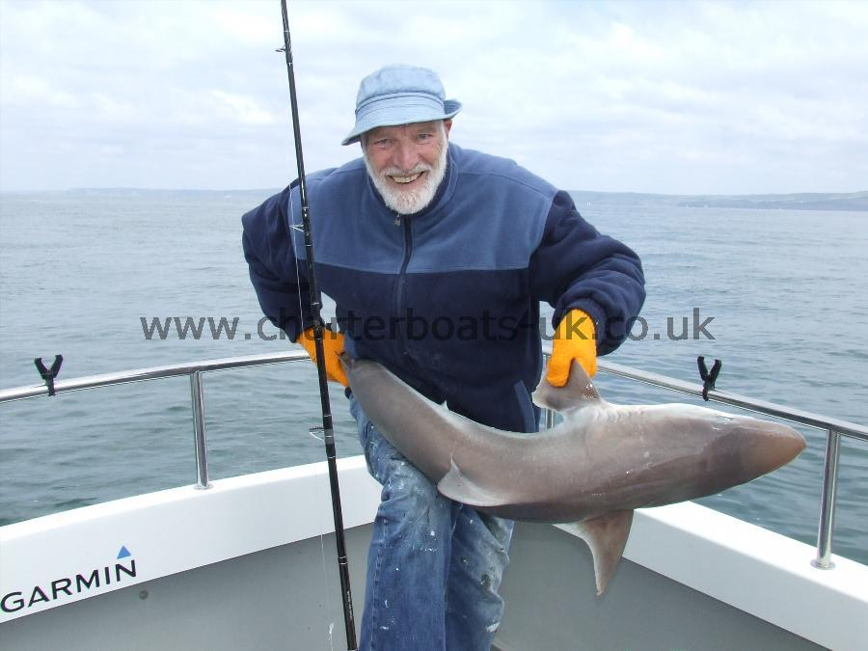
So much for a father's day present!
All fish were returned unharmed to fight another day

